Q1- Launch Firefox browser & navigate to https://www.seleniumeasy.com/test/javascript-alert-box-demo.html

Try to Fetch the alert popup text.

Try to Dismiss the popup.

Try to enter some data on an alert popup.

Try to accept the popup.

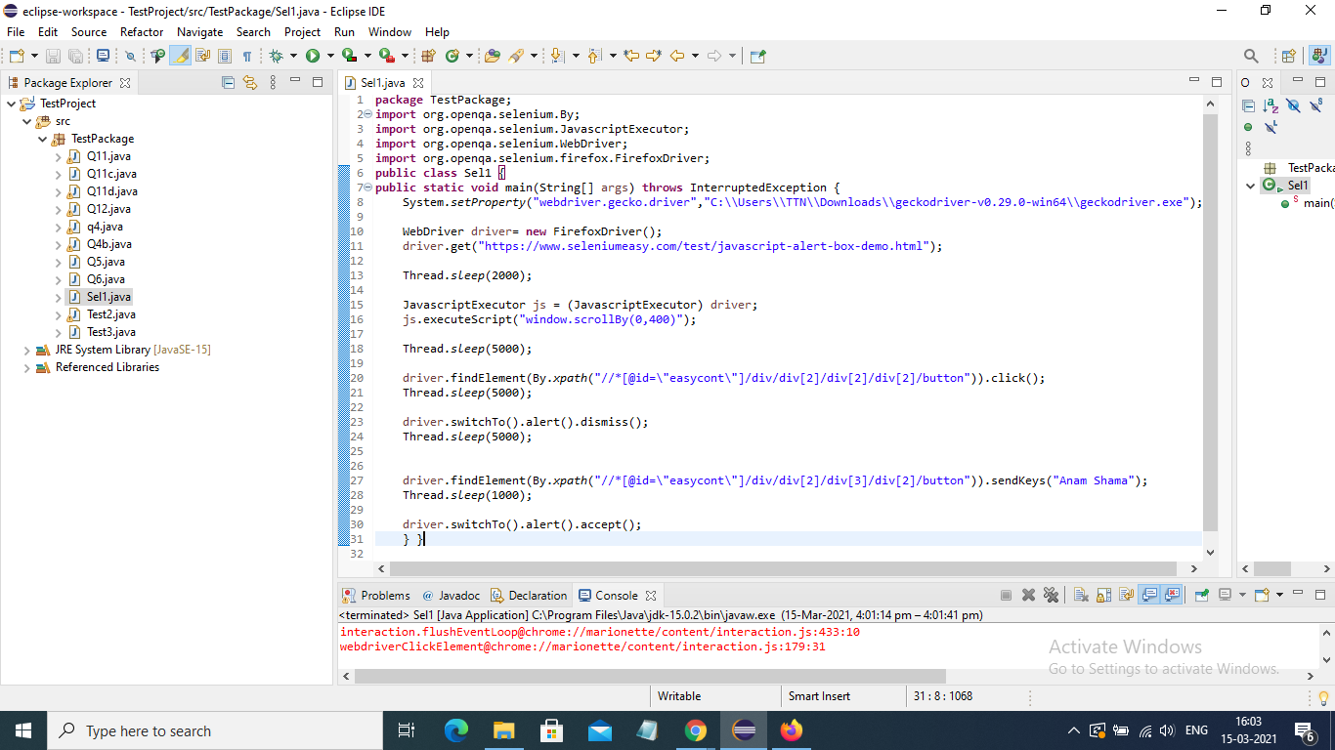

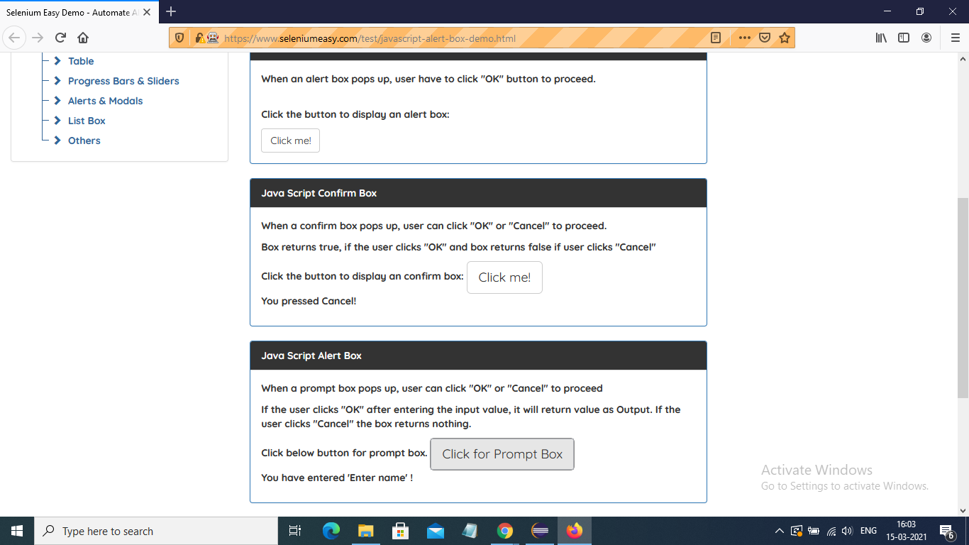

Q2- https://www.seleniumeasy.com/test/basic-select-dropdown-demo.html

Validate that Multi-Select List Demo is a multiple dropdown.

Fetch all the dropdown options

Select New Jersey>New York>Texas then fetch the last selected option & all selected options.

Deselect all the selected options.

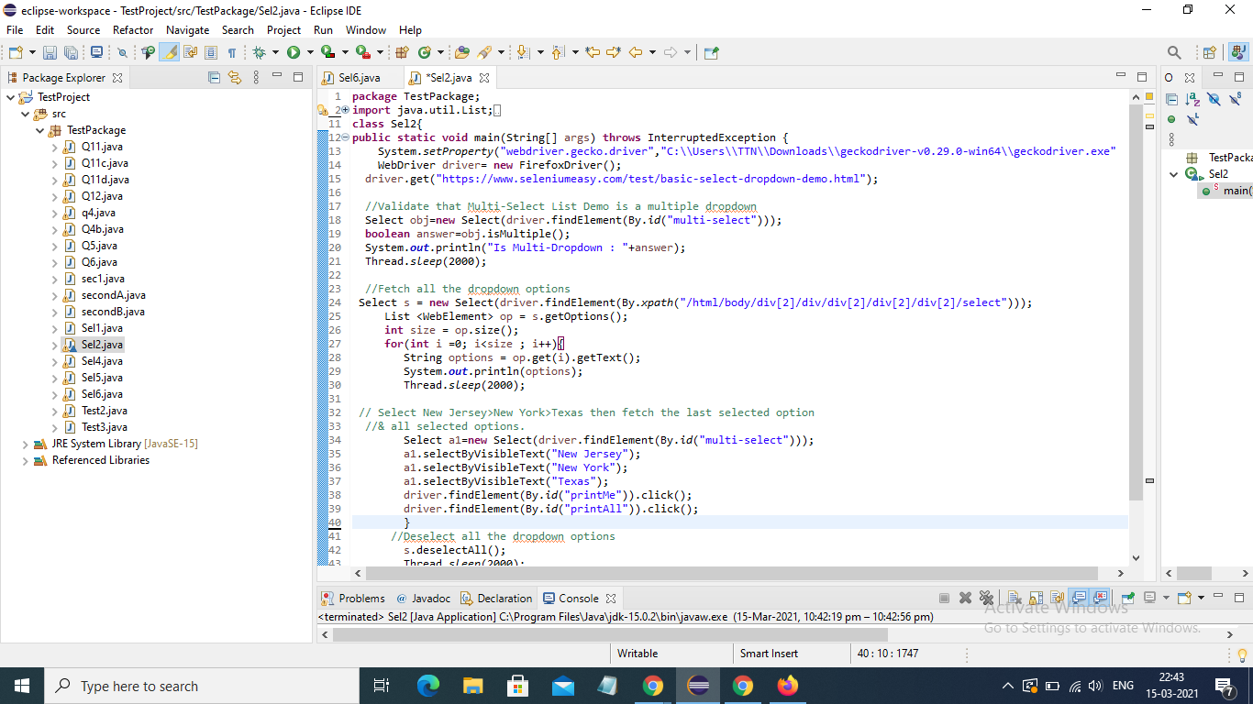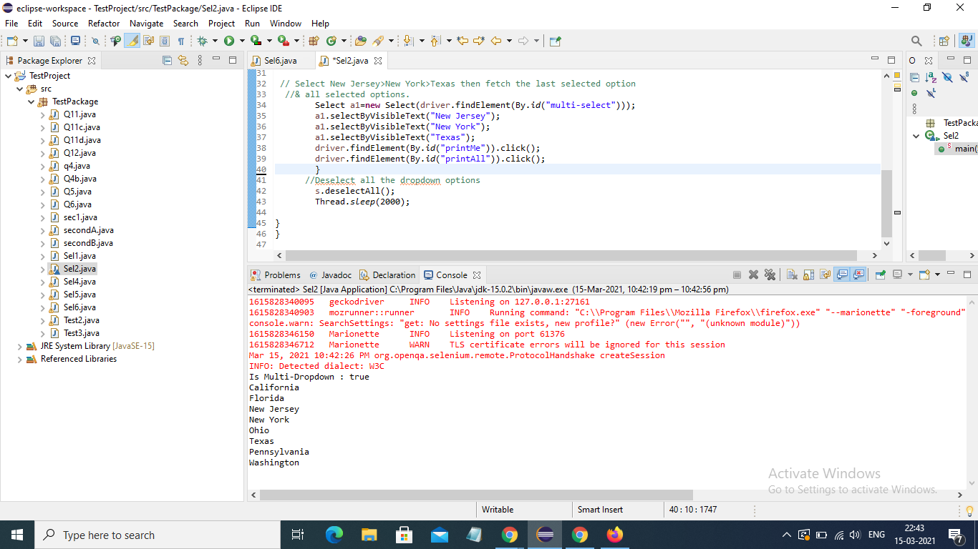

Q3- Difference between implicit & explicit wait along with syntax.

Ans: Implicit wait:

* Implicit wait is set for the entire duration of your webdriver and is set at the start of your program.
* What it does is, in case while executing, if your webdriver doesn't find any element then instead of throwing an exception, implicit wait makes your driver keep checking for that element for the given time. If the driver still does not find the element then it throws an exception.
* Implicit wait does the same for all the elements in our program, so you just have to set it once.
* Ex:Let'ssay that you give an Implicit wait of 20 seconds. Now while executing, your webdriver is not able to find an element, but since you've set implicit wait, the webdriver does not throw the exception right away. Lets say the time the webdriver searched for element is t=0. Now the webdriver keeps finding the element till t=21. If it finds the element within these 20 seconds then it performs the particular action on the element and if it doesn't, it throws an exception.
* Syntax:

WebDriver driver = new FirefoxDriver();

driver.manage().timeouts().implicitlyWait(20, TimeUnit.SECONDS);

Explicit Wait:

* Explicit wait works similar to Implicit Wait, but it works only on the particular element on which it is set rather than on all elements in your code.
* Also explicit wait tells the Web Driver to wait for certain conditions (Expected Conditions) or the maximum time exceeded before throwing an exception.
* Ex:If Explicit wait of 10 sec is set on an element with an expected condition and while execution the condition is false, at t=0, then it makes your driver keep checking for the expected condition till t=11. If the condition becomes true within these 10 seconds then it moves to the next step in your code and if it is still false at t=11, it throws exception
* Syntax:

WebDriver driver = new FirefoxDriver();

WebDriverWait wait = new WebDriverWait(driver, 10);

wait.until(ExpectedConditions.elementToBeClickable(By.id("id")))

Q4- http://demo.automationtesting.in/Frames.html

Enter the value in the field under single Iframe as well as Iframe within an Iframe in a single script.

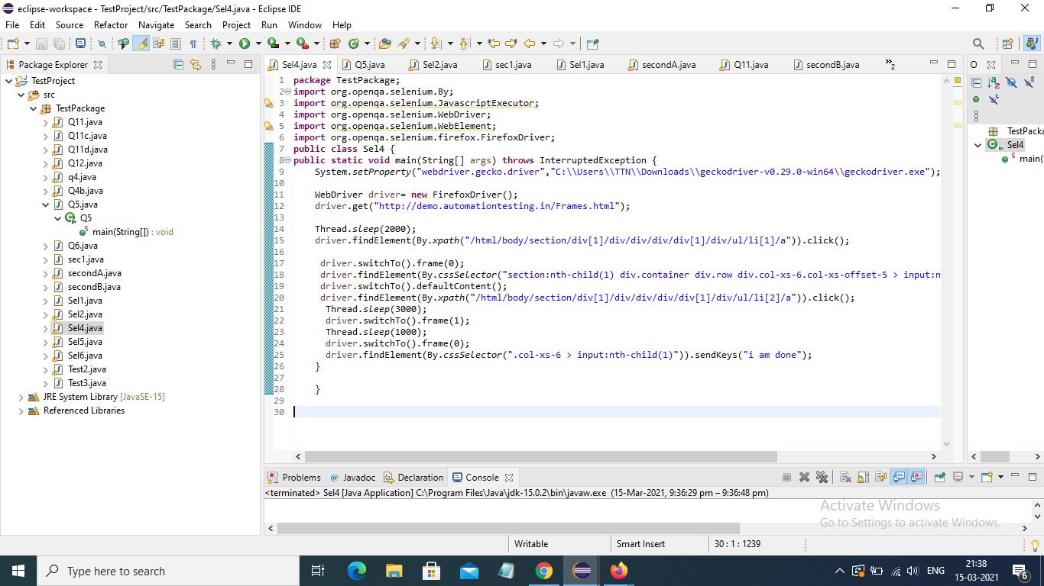

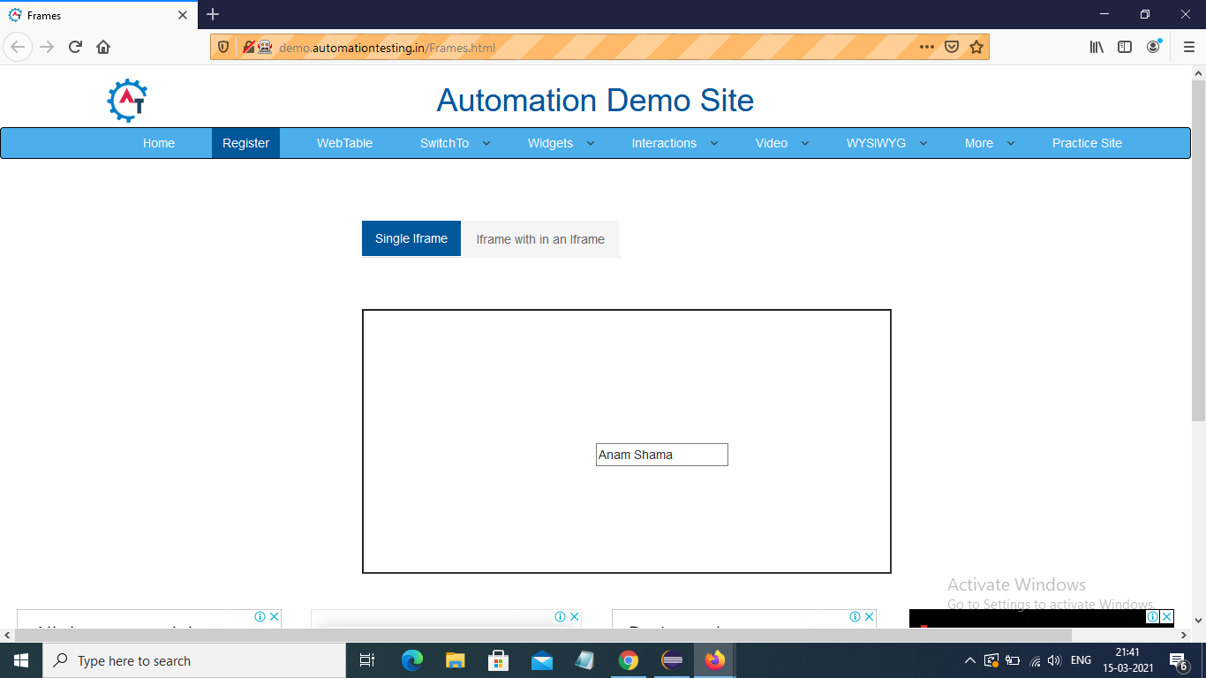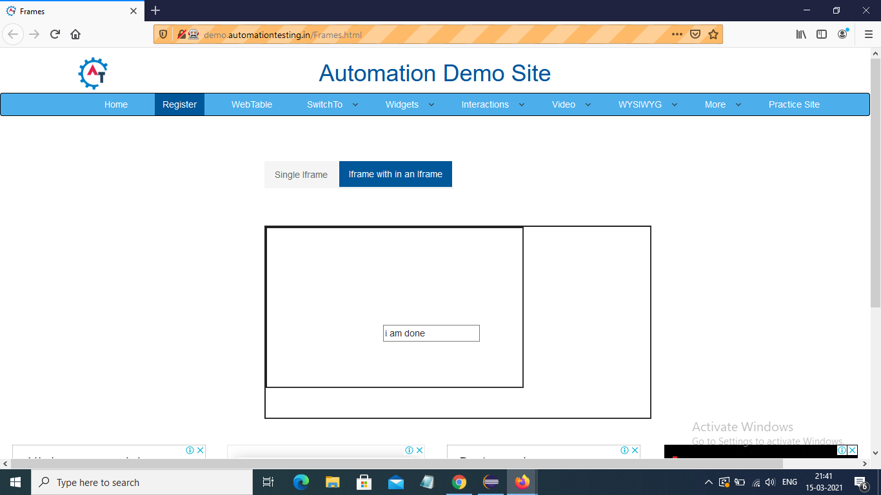

Q5- http://demo.automationtesting.in/Frames.html

Print the count of frames on this application.

Print and switch to inner iframe

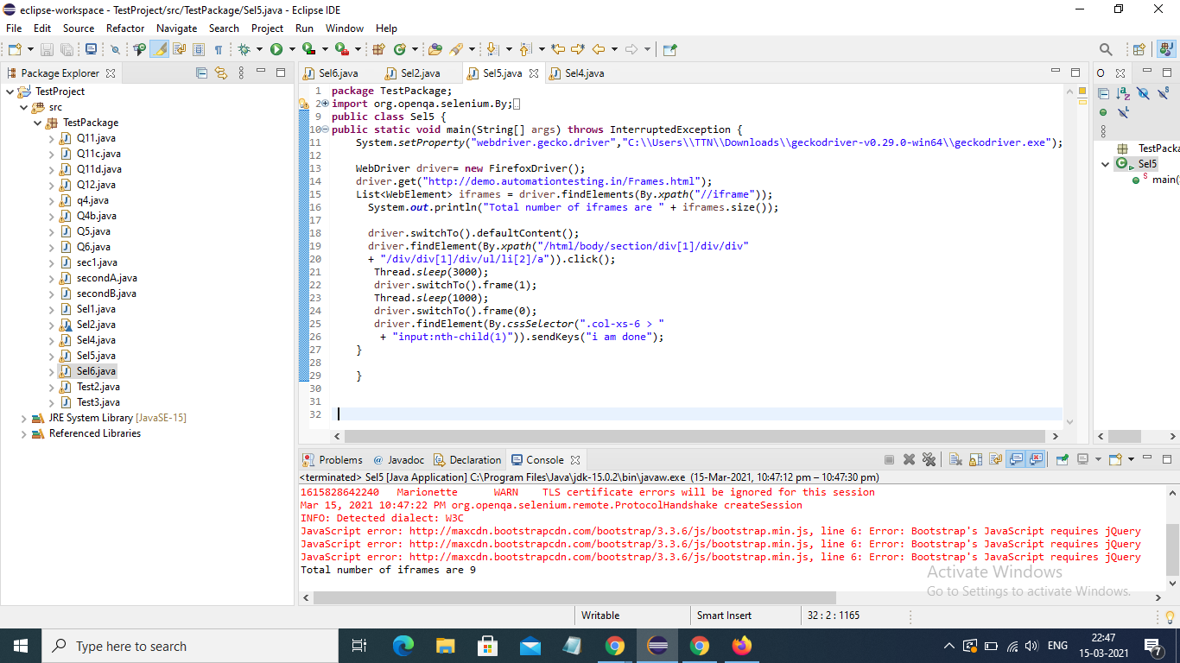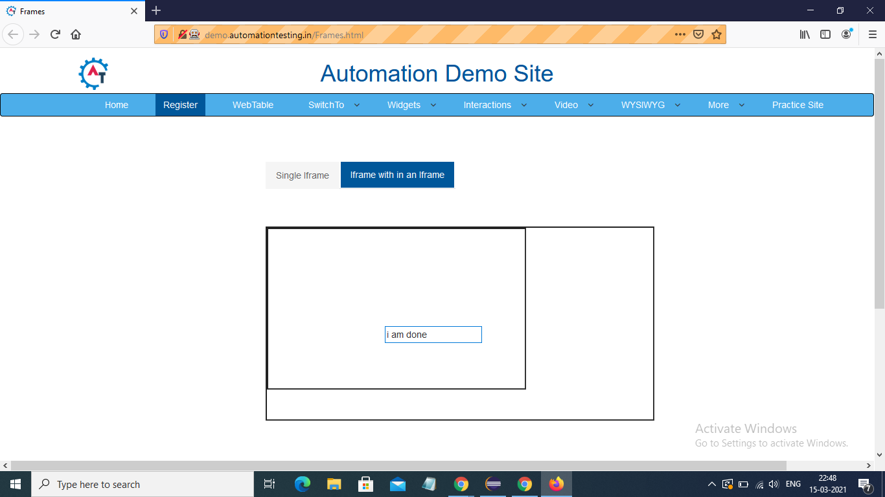

Q6- https://www.toolsqa.com/automation-practice-switch-windows/

Click on New Window Message Tab then print the title and text in the newly opened window, then switch back to the main window.

